154 3AR
3/10/20
3/11/20
GM. CAI 91@choicehotels.com Check In Time: 3/10/20 3:27 AM
 | Check Out Time.
TELEVISORA DE HERMOSILLO, S.A DE | Rewards Program ID.
BLVD LUIS ENCINAS Y OLIVARES | You were checked out by:
VILLA SATELITE | You were checked in by: | agarci
HERMOSILLO, SON 83200 | Total Balance Due: | 0.00
Post Date Amount
3/10/20 | Cash | (123.20)
3/10/20 | Security Deposit | (100.00)
3/10/20 | Room Charge | 109.00
2/10/20 | CA Tourism Assessment Tax | 0.03
3/10/20 | Occupancy Tax | 14.17
3/10/20 | Guest Refund | 100.00
-
Room Charge |  | 109.00
CA Tourism Assessment Tax |  | 0.03
Occupancy Tax |  | 14.17
Cash |  | (123.20) /
Guest Refund |  | 100.00
Sect Irity Deposit |  | (100.00)
 | Balance Due. | 0.00
This rate is eligible for partner rewards. If this rate is changed, you may no longer be entitled to partner rewards.
x

C
JOjn vwvw.cnoiceprivileges.com.

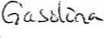
ARCO GASOL I NE ARCO AMPM #42960
44-333 GOLF CENTER PKWY INDIO, CA AR%42960001

***PREPAID RECEIPT***
Description Qty Amount
PREPAY 다 #18 35.00
Subtotal 35.00
Tax 0.00
TOTAL 35 - 00
CASH $ 35.00
THANK YOU FOR CHOOSING ARCO COMMENTS?
CALL 1-800-322-2726
•• L XXXX DR# 1 TRAN# 1016889
03/10/20 10:02:27
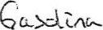

ARCO GASOL NE

ARCO AMPM 42852
201 FRAZIER MTN RD LEBEC CA hRC042852001

***PREPAID RECEIPT***
Description Qty Amount
PREPAY CA #05 30.00
Subtotal | 30.00
Tax | 0.00
TOTAL | 30 - 00
CASH | 50.00
Change | -20.00
THANK YOU FOR CHOOSING ARCO COMMENTS?

CALL 1-800-322-2726
ST# 42852 TILL XXXX OR# 1 TRAN# 1027473
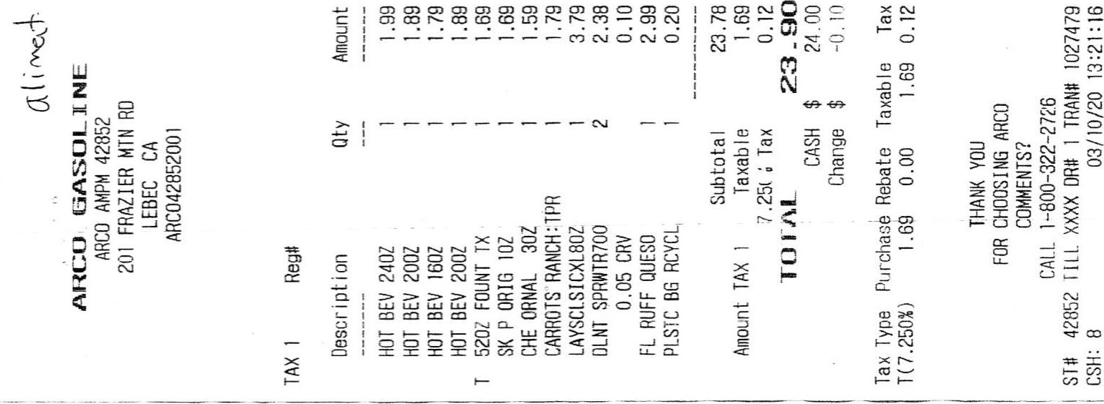
CSH: 8 03/10/20 13:08:25

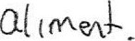

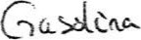
ARCO GASOLINE
ARCO AMPM 42385
ARCO GASOLI NE |  | 3030 E TULARE AVE
ARCO AMPM 4238S |  | FRESNO, CA
3030 E TULARE AVE |  | 559-441-1173
FRESNO, CA 559-441-1173  ARC04238SOOl |  | ARC0423B5001  TAX 1 Reg#
 |  | Descr i pt ion Qty | Amount
Dascript I on Qty | Amount | T F REFILL45&r-iVR | I .59
 |  | HOT BEV 1602 | I .99
PREPAY CA tca 35.00
 |  | Subtotal | 3.58
Subtotal 35.00 |  | Amount TAX I Taxab le | .59
Tax 0.00 |  | 7.975% Tax | 0. 13
TOTAL 35 -oo |  | TOTAL | 3-71
CASH 50.00 |  | CASH | 5.00
Change -15.00 |  | Change | -l .29
THANK YOU |  | THANK YOU
FOR CHOOSING ARCO |  | FOR CHOOSING ARCO
COMMENTS? |  | COMMENTS?
CALL 1-800-322-2726 |  | CALL 1-800-322-2726
42385 TILL XuX DR$ i TRAW 1016754 |  | 42385 TILL XXXX 1 TRAN# 1016762
03/11/20 | CSH: 4 03/11/20 16:47
CSH: 4
Dine In
Cenny's Restaurant #6203
3120 North Blackstone Avenue |  |  | Denny's Restaurant #6209
 | Fresno, CA 93703 |  | 3120 North Blackstone Avenue
 | (559)227-7151 www.dennys |  | Fresno, CA 93703 (559)227-7151
Order: | 616240 Server: Ivette G |  | 3/12/2020 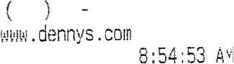
Table: | 36 Guests: 6  Orange Ju |  | Order: 618234 Server: Ivette G
 |  |  | Table: 34 Guests: 2
 | Sig Diner Ccffee | 3. 19 | Diner Ccffee | 3.19
 | Wild West Omelette | 1 1 | 55+ Omelette
 | Sig Diner Ccffee | 3.19 | 55+ Omelette | 8,39
 | Wild West Orelette | 11 | Add Ch/ON/GR | 1 .39
 | Add Avocato | 1 .29 | Oatmeal | 2.39
 | Sig Diner Coffee  Phi I ly ChsSteak Omelet | 3.19 | AARP 1 | 3.70
 | Add Avocado | 1 .29 | SubTota | 20 .35
 | Add Jalapenos |  | Tax | 1 .37
 | Orange Ju  Ultimate Omelette Add Avocado  Add Jalapenos  Sig Diner Ccffee | 12.49 1 .29  o. 39 3.19 | Total
 | Lumberjack Slam | 12. g | Cash
 | Sig Diner Ccffee | 3.19 | Change | 0.38
 | All Amer | 12.49
 | Add Jalapenos |  | Visit us again in the next seven days and SAVE!
 | SubTota1 Tax | 103 .il | Bring in this receipt for
Dine In
Total 1 1 1 .76 20K off our entire checkt
Cash 113.30  Charge 1 .24  Visit us tgain in the next seven cays and SAVE! Bring in this receipt for  20% off our ^{p}ntire check,  IIII IIII IIllI IIII IIll IIIII IlI II Il IIIl IIII | Offer valid for 7 days after original purchase. Dine in only. Not valid with other discounts. Alcoholic beverages not included. Redeemable only at:  Denny's Restaurant #6209  3120 North Blackstone Avenue  Fresno, CA 93703  Join Denny's Rewards to get off or your next visit . Sign up no:" at
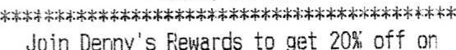
8 8 8 2 2 0 Dennys.com/Rewards.
Offer valid for 7 days after original purchase. Dine in only. Not valid with other discounts. Alcoholic beverages not included. Redeemable only at:
Cenny ^{t} s Restaurant #6209
3120 North Blackstone Avenue

Fresno, CA 93703
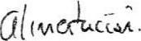
See back Of receipt for your chance
See back if receipt for your chance tu Uin 1b to SIOOO ID g:7P7THZlYZL3U Waimavt
Walmart 559-470-69671804 EAST ASHLAN AVENUE
559-470-6967 Hgr:JONATHAN FRESNO, 9
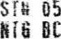
1804 EAST ASHLAN AVENUE 05632 00135b 63 07372 FRESNO, CA, 93726SRB 007050107000 5.58

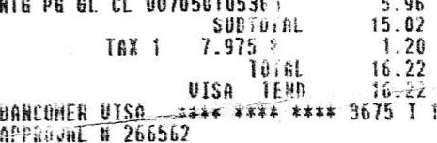
05632 001429 0240b EQ HUR TUL 0681131030.9 3.40
PG
GL
CL
00705010531
5.96
x
NTG
PADE FRT PCM 004900007938 F 0.80 K CRU FEE 068113176539 F 0.10 0 PADE LEH LIH 004900007937 F 0.80 H
CRU FEE 0681 13176539 F 0.10 c BERRY 004900007935 F 0.80 CRU FEE 068113176539_F 0.10 0
LEH LIH 004900007937 F 0.80
CRU FEE 068113176539 F 0.10 0 RE. 007300i44i35
PADE FRT PCH 004900007938 F 0.80TRAks ID - 3800130d4333462
CRU FEE 0681 13176539 F 0.10 0RK3H
PADE FRT PCH 004900007938 F 0.60 N PAYMENT SERVICE - E

HTH CRU FEEBERRY 060113176539004900007935 0.80 AID 3B06FFE4fC121CAOA0000000032010 CRU FEE 068113176539 0.10 0 TERMINAL
FRUIT CUP 0681 13130537 1.98 K *Pin Verified
FRUIT CUP 068113130538 F 1.98 03/12/20
FRUIT CUP 068113130530 1-98 CllAHGE DUE 0.00 TOST QUESO 002840007098 F 3.98 H ITEMS SOLD 3

FRUIT DIET CRU FEECOKECOKECUP 004900006105068113130537 004900006105007874235151 F 2.76 0.30 2.761.96 Tx I II i ^{I I}II 6689 IIIlIIIIIll 6334 IlI IIIIII7316 i IIIIlIlIlI7646IlI II IllIIIIlIIlII IlIIII I II III
DIET
FEE 007874235151 F o.Lou Prices You Can Trust. Every DåY.

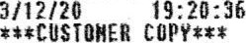
MINI PRTZL 007797508006 2.98 N
03/12/20
TROP 6PK OJ 004850000629 F | 3.97 0
TROP 6PK OJ 004850000629 F | 3-g7 0
tm'S 002840019914 | 2.68
004900006101 | 2.76 x
CRU FEE 007874235151 | 0.30 r
COKE 004900006101 F | 2.76 x
CRU FEE 007674235151 | 0.30 T
FRUIT CUP 068113130537 F | 1.98 N
DORITOS 002840064306 F | 3.48 N
OREO 004400003325 F | 3.52 N
FRUIT CUP 060113130538 | 1.98
FRUIT CUP 068113130537  CARRYBA6 FEE 000000001101K | 1.98 N
FOR 0.10 | 0.40 0 | See back of receipt for your chance
SUBTOTAL | 60.82 | ID n:7P7TNQIYZRPN
7.975  TOTAL | 0.98  61.80 | Walmart
VISA TEND | 40.00
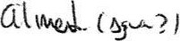
3 ORANGES 005410722101 F 3.44 K
BANCOHER VISA0949 1 i 559-470-6967 Hgr:JONATHAN
APPROVAL 348931
REF 1042000314

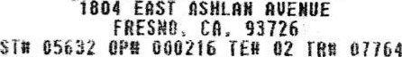
TRRYS ID - 460073090773061 000216 02
UAL IDRT CWT | PRIM) | oog7709010C2 F | 1 .00 H
PAYMENT SERVICE - E |  | 000000009503 F | 0.39 K
AID 90000000031010 |  | 009770901002 F | 1 .00 N
TC D2EA88E6298F7?9A | PRIMO | 000000009503 F | 0.39
TE'.UIINAL # sc010507 | PR IMO | 009770901002 F | 00 N
*Pin Verified | PRIHO | 000000009503 F | t:39 N
03/12/20SUBTOTAL 4.17
TEND 100.00 4.17
DUE 76.20 |  | CASH TEND | 5-00
ITEMS SOLD 41 |  | CHANGE DUE | 83
1727 7506 5797 5581 5492 |  | ITEHS SOLO 6
 |  | -rcv 2679 6133 7376 | 6021

IIIILou IIlI IIIIPrices I II II! ! ^{I}I IIIlYau IIII IIIICan IIIlI I II ITrust. Il IlIII I I IlIII IEvery I! IlII IIII Day.IIl IIlIIIlIIlIll! IIIIiIIIIlII^{I} I^{l}I IIIliIIIliIIIlI II IIllIlIlIIIlI IIIlIIIIl IIIiI IIIIIII IlII IIIIIII IIII IIII
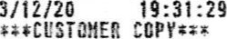 Luu Pt ices You frust- Every
03/12/20

ARCO GASOLINE 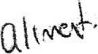
FRESNO , CA |  |  | ARCO GASOL
ARC042194001 |  |  | ARCO AMPM 4285z  FRAZIER MTN RD  LEBEC CA  ARC0428S2001
***PREPAID
Descript i on |  | Amount
PREPAY CA |  | 20.00 | Amount

ARCO 42194 3703 BLACKSTONE AVE

I .99
I .89
1 .79
1 .99
I .99
1 .99
1 .99
1 .99
4 .99
20.61 o .00
20
21 .00
$ -0.39

Subtotal 20.00
Tax 0.00

TOTAL 20 - 00
CASH $ 100.00
Change -80.00
THANK YOU FOR CHOOSING ARCO COMMENTS?
CALL 1-800-322-2726
42194 TILL XXXX I TRAN# 1026325
CASH: 5 03/12/20

ARCO GASOLI NE
ARCO AMPM 42852
201 FRAZIER MTN RD
LEBEC CA

ARC042852001
Descr i pt i on Qty Amount
PREPAY CA $03 30.00
Subtota I 30.00

Tax 0.00 TOTAL 30 - 00
CASH _$ som
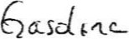
Change $ -20.00

THANK
FOR CHOOSING ARCO COMMENTS?
CALL 1-800-322-2726
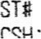
42852 TILL XXXX I TRAN* 1029239

Description Qty
HOT BEV 240Z
HOT BEV
HOT BEV
HOT BEV 240Z
NT&FRT :MX2.25? LORS.2S OZ
2 CRUMB CAKE
HOT BEV 2402
RPSGNA/STWBY8Z
Subtotal
Tax

TOTAL

CASH
Change
THANK you FOR CHOOSING ARCO COMMENTS?
CALL 1-800-322-2726
We I con 42852 TILL XXXX I TRAN# 102923B

CSH: 11 03/13/20
¯4öi55TTLLONÆO
COACHELLA CA 92236
RECEIPT
Descr i Dt ion Qty Amount
PREPAY CA 30.00
Subtotal -30.00
Tax 0.00

TOTAI 30 - oo
CASH $ 30.00
Pi ease come again
Store Manager : 760-342-6200
1

041 TILL XXXX 1 1014317

STORE 1180
41112 West Indian School Road
Tonapah. AZ 85354
03/13/2020
SALE
Qty Name price Total

1 Prepay 40.00 40.00 Pump :
Gal Ons : 1.000

Price 4"
40.00
moo
Total 40.00

Rece i ved :
Cash 50.00
Change Due Cash -10.00
6cS
118002200087
Pos:2 Clerk:136 03/13/2020
#ORIGINAL RECEIPT
Auto esel PPG Includes $. 18 AZ excise
This diesel fuel contains no visible evidence of dye: FEO ID #34-1953155
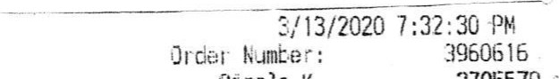
Circle
K
2705579
653 22ND ST
Tucson, AL
(520) 798-3215
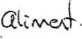
c 127
COC
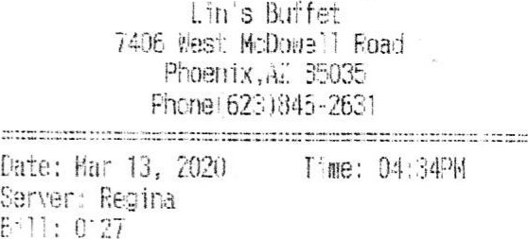
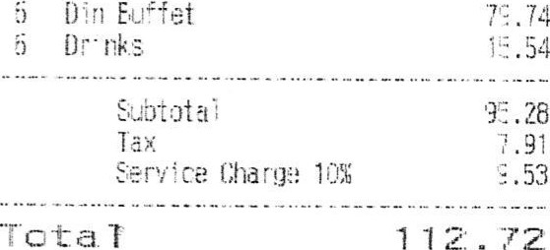
back of receipt for your ch:nce

to win $100() ID fi:7P7TTCH8TBC

Walmart
520-625-3803 Mgr:JOE

18680 S NOGALES HWY SAHUARITA AZ 85629
01411 OPt1 009046 46 05492 FOG FACN VAN 002550006764 F3.72 0 FREN VAN 002550006764 F 9.72 0
SUBTOTAL 7.44
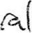
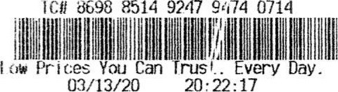
TOTAL 7.44 CASU TEND 20.00 CHANCE DUE12.56 # ITEMS SOLD ?

S, James
prepay Pulltp # 7 $25.00

Sub. Total : $25.00
$25.00 Ois-mnt iota l:
Cash $25.00 Change $0 - 00
 | CQC/ | DIP.

$0.00
Fuel Rate $.18

Thank You
Come Aga i rt

Customer Service Hotline

